WEEK - 12

WEEK – 12 USER DEFINED FUNCTIONS REG NO : 240901086

NAME : RENUGADEVI S Q1)

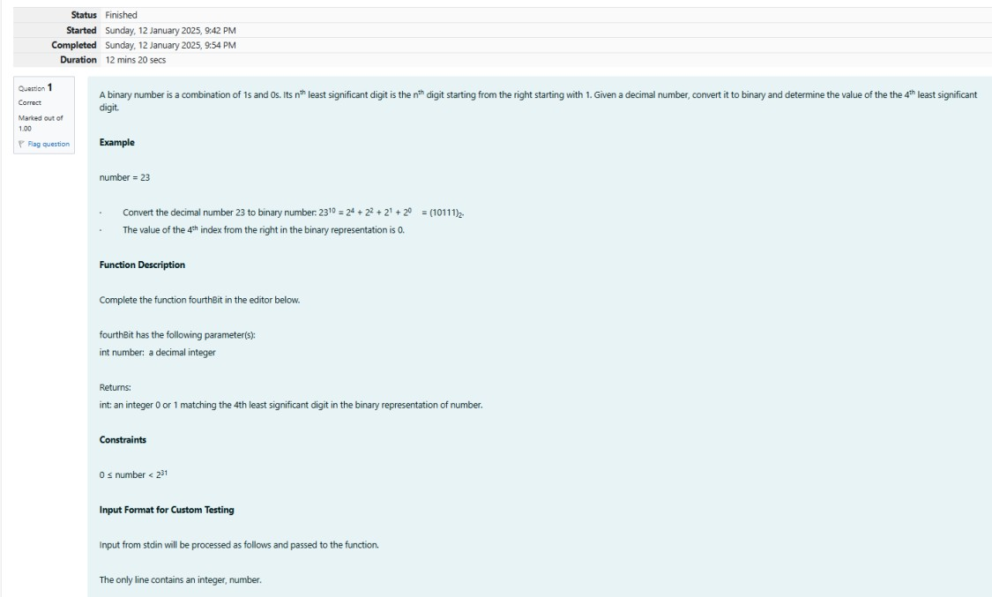

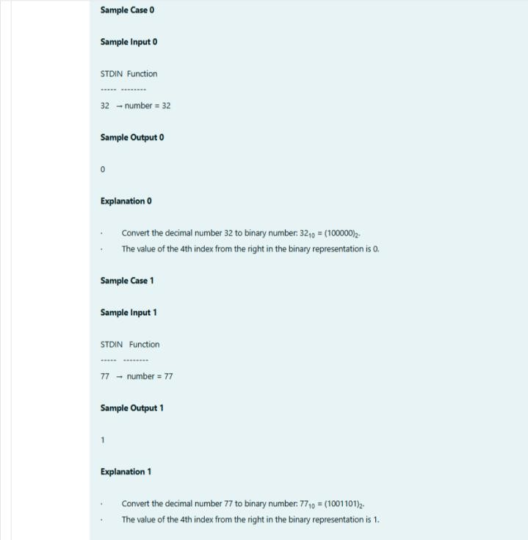

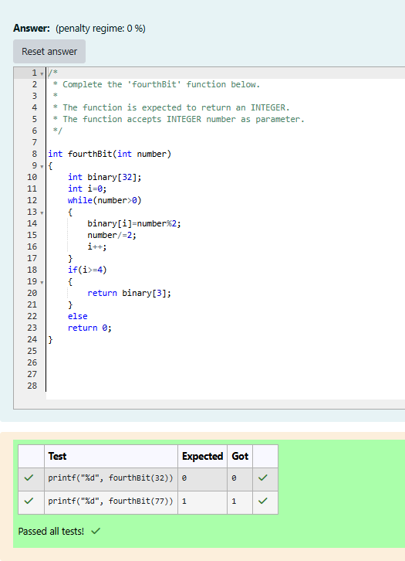

WEEK – 12 USER DEFINED FUNCTIONS REG NO : 240901086

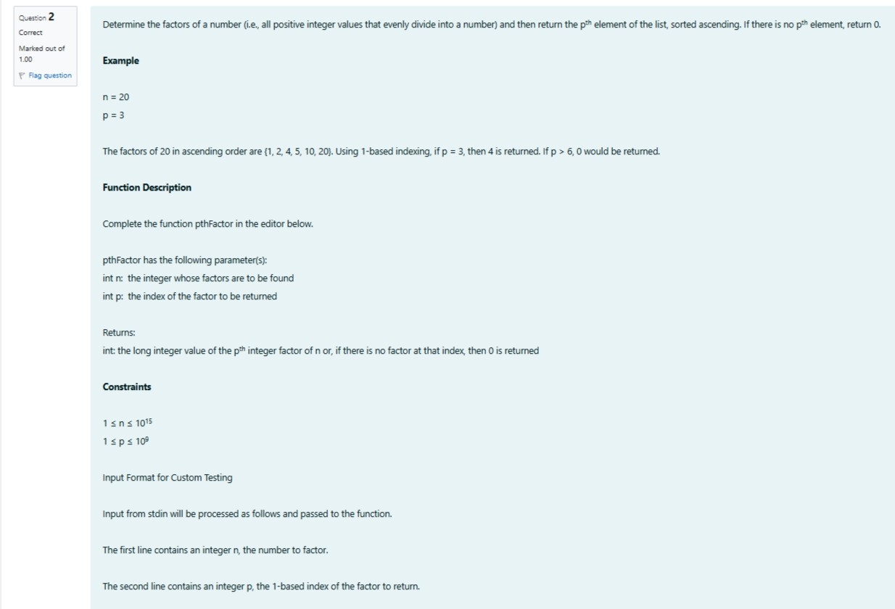NAME : RENUGADEVI S Q2)

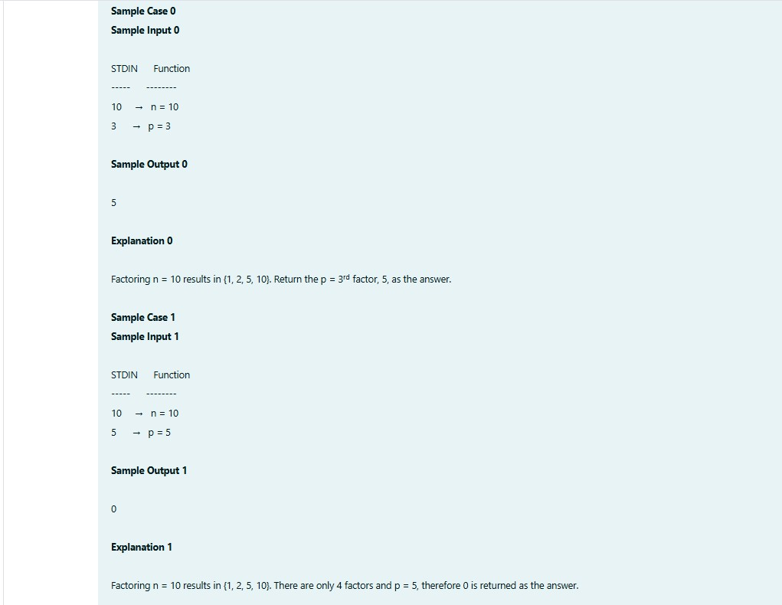

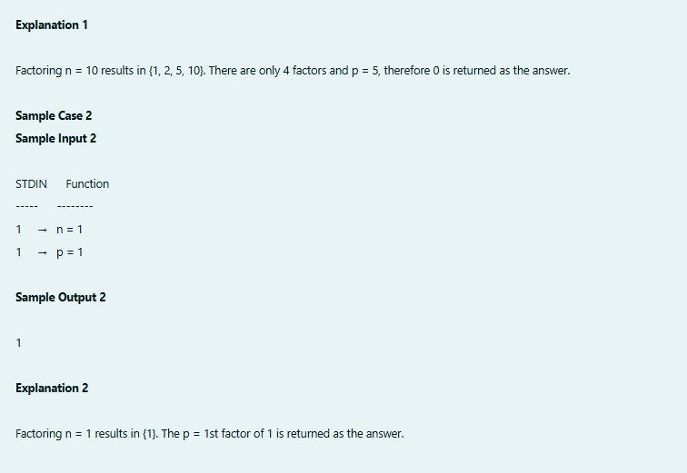

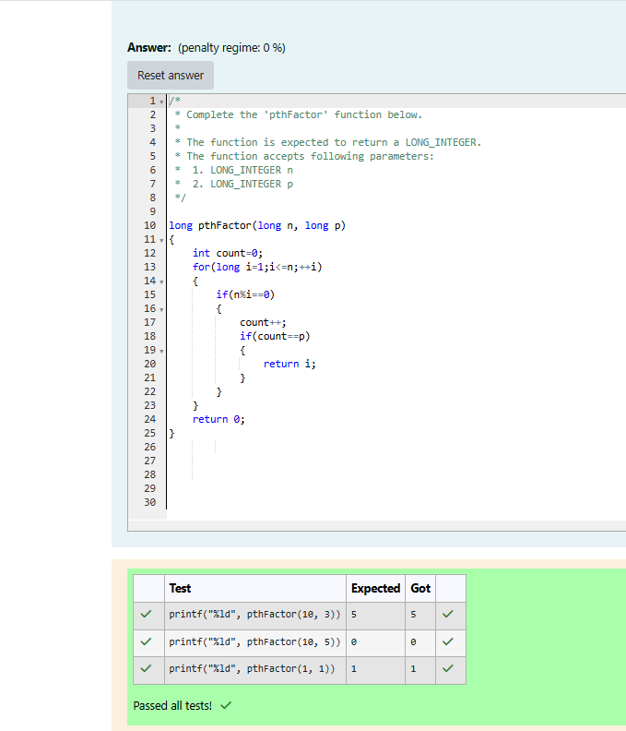

WEEK – 12 RECURSIVE FUNCTIONS REG NO : 240901086

NAME : RENUGADEVI S Q1)

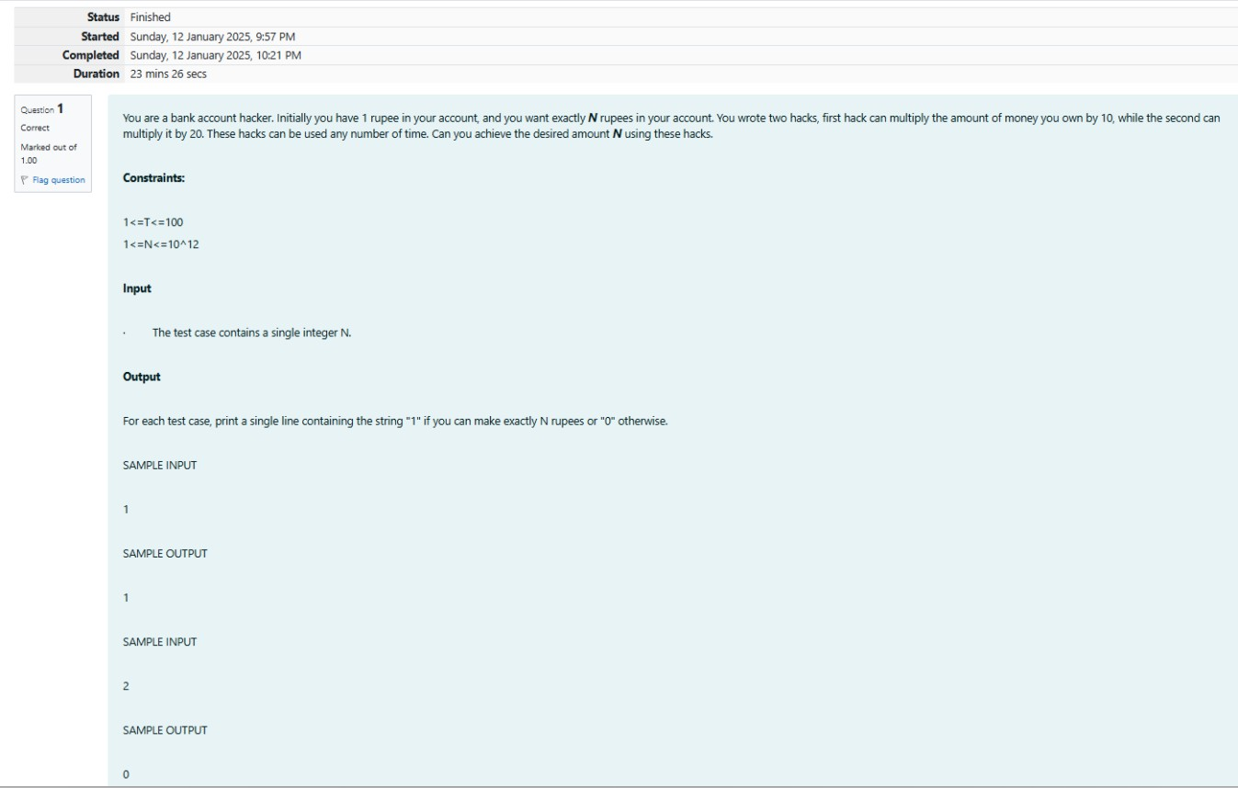

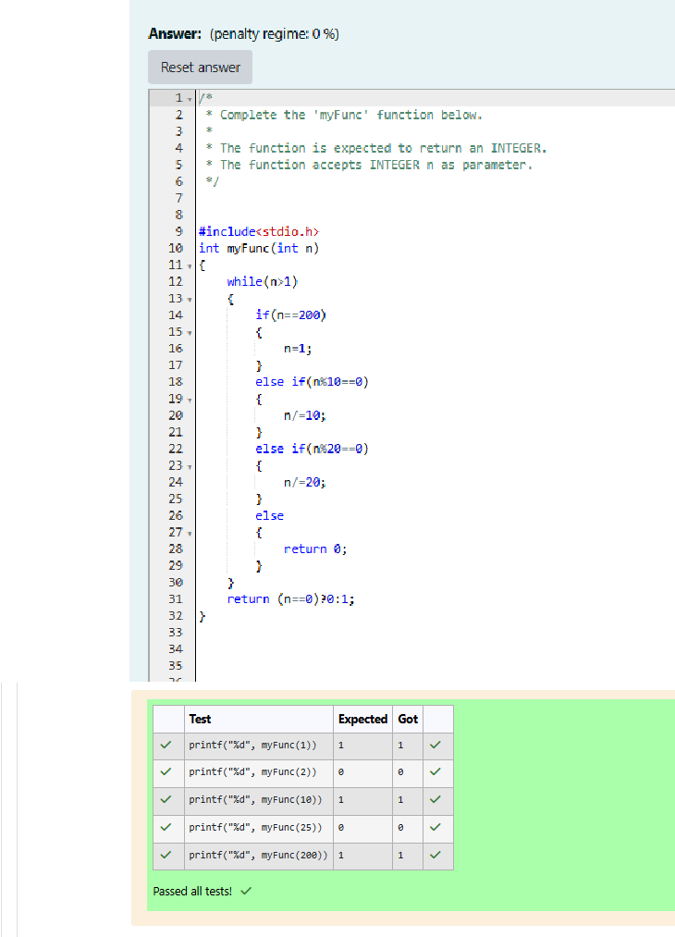

WEEK – 12 RECURSIVE FUNCTIONS REG NO : 240901086

NAME : RENUGADEVI S Q2)

